Trading with Market Internal $ADD
By Jaime Ness
$ADD is the NYSE Advancing Issues – Declining Issues
$ADD is the ticker symbol with Think or Swim

I use the 5 minute chart to view $ADD. After the open make sure you watch the early trend before entering a trade. I would recommend watching the first 15 minutes to determine the trend. We can and do often have gap up/down and trap. Always remember news can hit at any time and the buy/sell programs will over power market internals. Please note these are all just general guidelines that I have learned over the years.

General Information

- ADD is 500 to -500 we will basically have a normal choppy day.
This is the perfect day to sell O-DTE SPX Iron Condor or Iron Fly.

- ADD is 500 to 1000 SPX will be green at least $10.

- ADD is 1000 to 1500 SPX will be green at least $20.

- ADD is -500 to -1000 SPX will be red at least $10.

- ADD is -1000 to -1500 SPX will be red at least $20

Extreme days

- ADD is 1500 to 2800 always go with the trend and sell OTM Puts near the open. Don’t sell the call side till at least 2.5 hours after open. Pullbacks will be very shallow on these days. High odds that the high of the day will come in the last hour of trading. Never try to guess how high we can go.

- ADD is -1500 to -2800 always go with the trend and sell OTM Calls at the open. I never recommend selling the Put side on days like this. All rises with be very shallow on these days. High odds that the low of the day will come in the last hour of trading. Never try to guess how low we can go. If we close at the lows I always buy some calls for the next day and sell OTM puts.

- There are 2800 NYSE stocks so + or – 2800 in the max. + or – 2000 is an extreme.

Below is a typical +1500 day

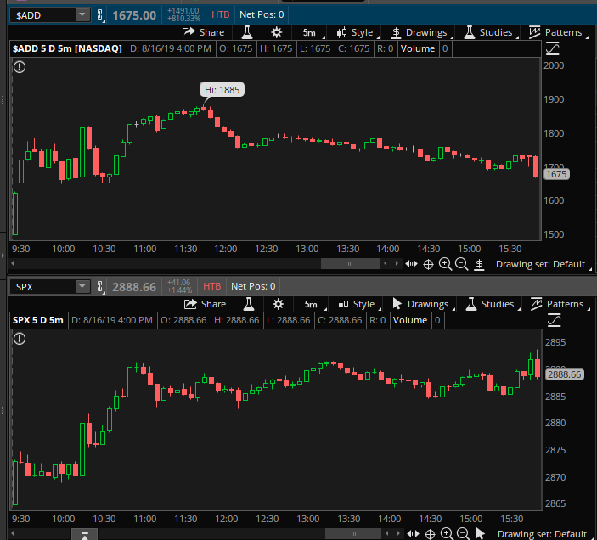

Below is a typical -1500 day.

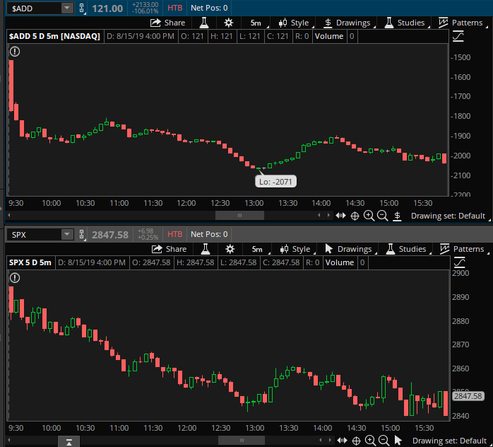

Below is an example of a gap down with -1333 in $ADD. Notice it immediately started trending up. This is a classic gap down and trap. Notice the that the first 4 5 minute candles that SPX was falling and $ADD was rising. When you see this divergence at the open sell the puts and wait till $ADD hits 0 to sell the call side.

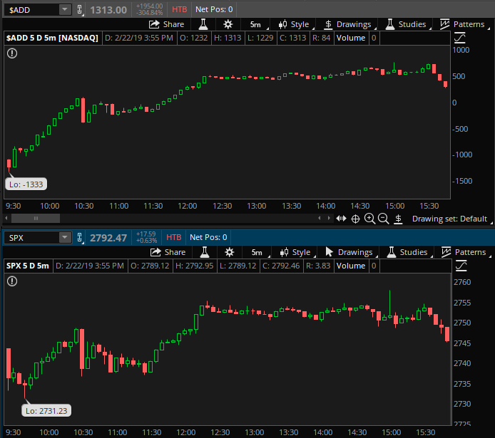

Below is an example of a gap up with +1000 in $ADD. Notice it immediately started trending down. This is a classic gap up and trap. Sell the put side when $ADD hits 0. I usually go long /ES when we gap up and then $ADD hits 0.
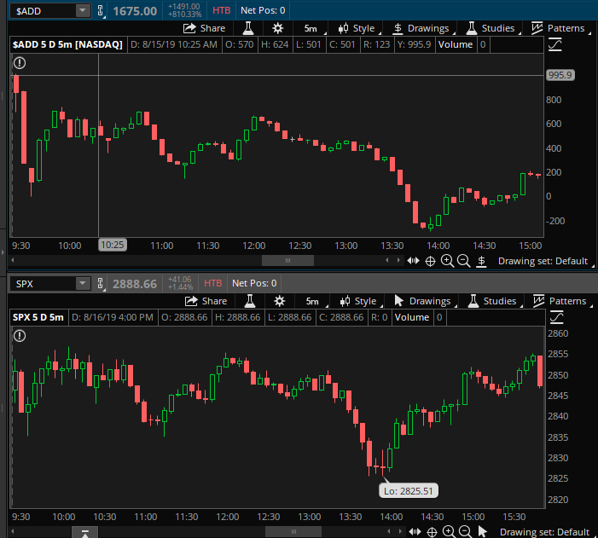

Classic gap up and fall of $ADD. Notice SPX price was rising while $ADD was falling. Negative divergence is when the odds are in your favor to sell OTM calls.
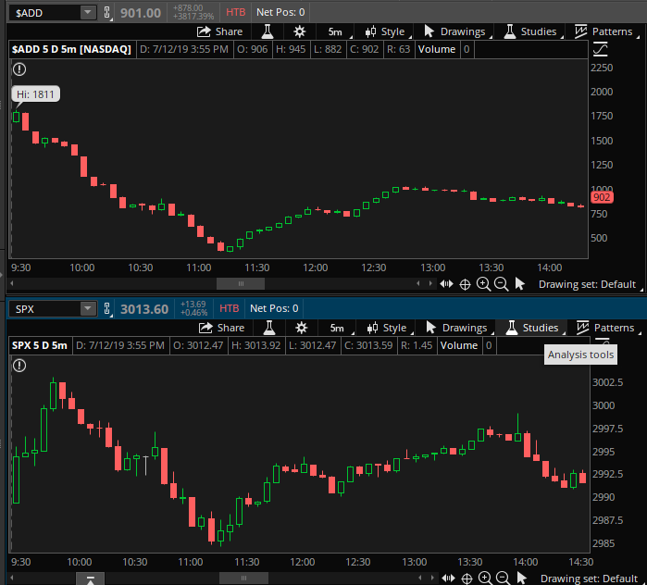

Classic gap up and fall of $ADD. Notice SPX price was rising while $ADD was falling. Negative divergence is when the odds are in your favor to sell OTM calls. Sell the put side when $ADD hits 0. I usually go long /ES when we gap up and then $ADD hits 0.
